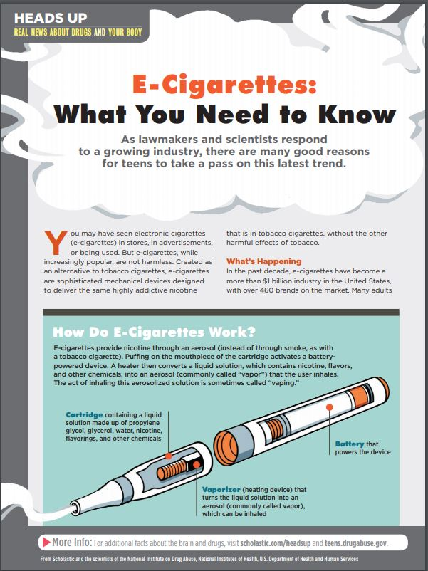

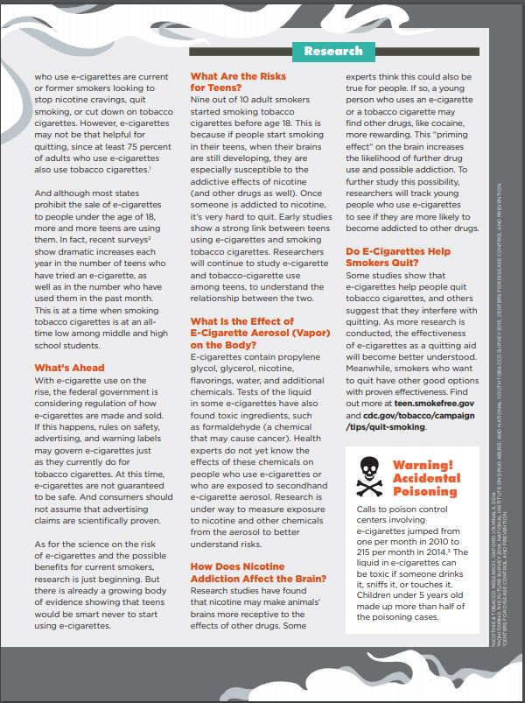

Name : Critical thinking questions
- How are e-cigarettes (vapes) similar to tobacco cigarettes, and how are they different?

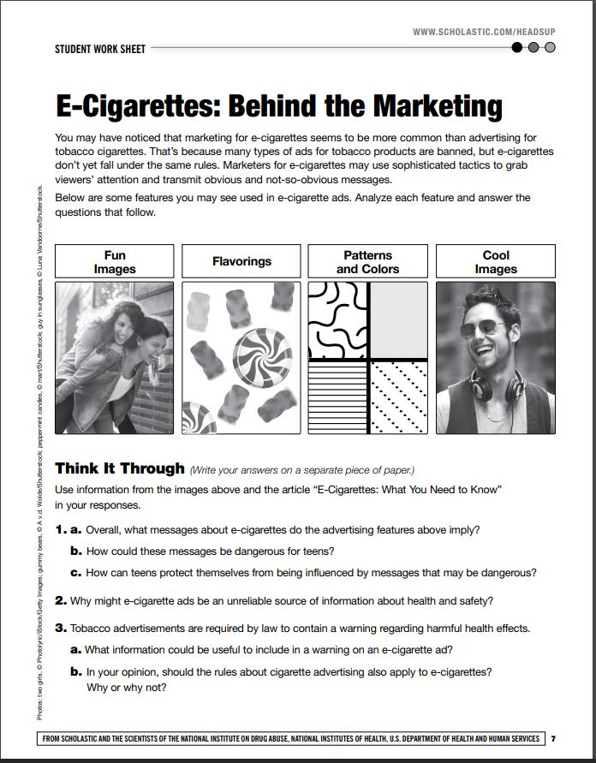
- What are some risks of e-cigarettes (vapes) to teens?

